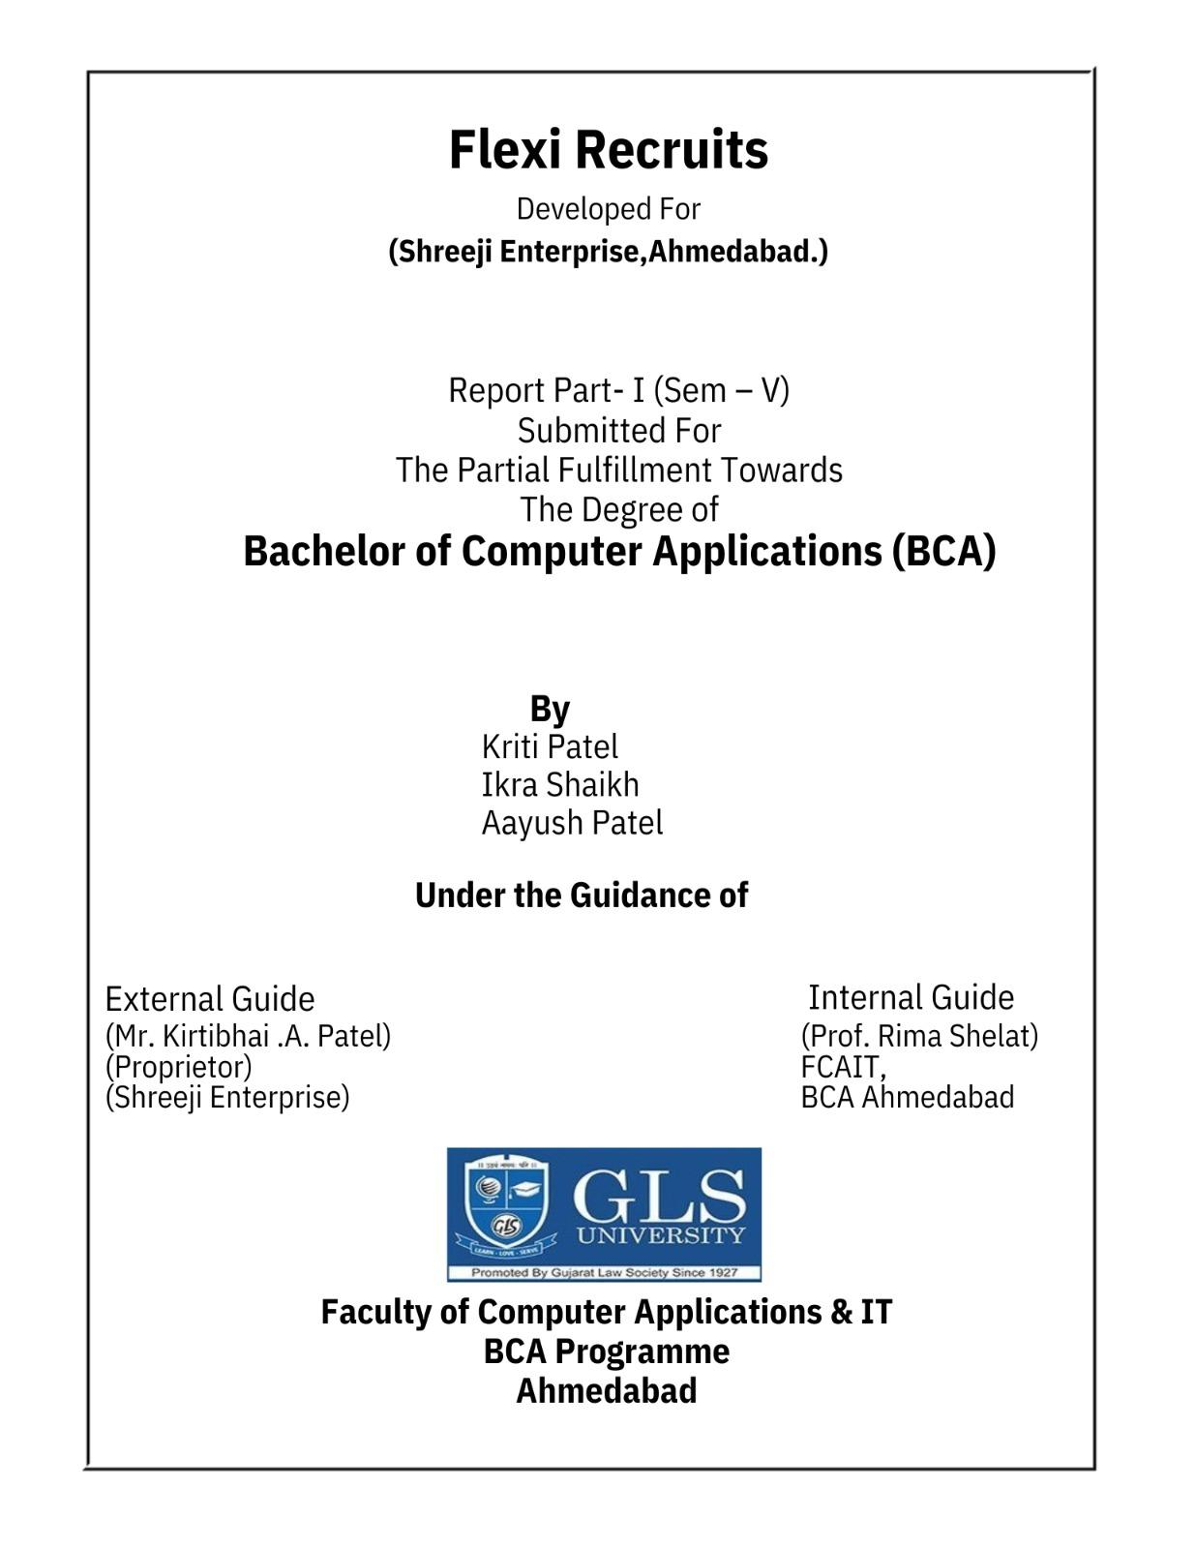

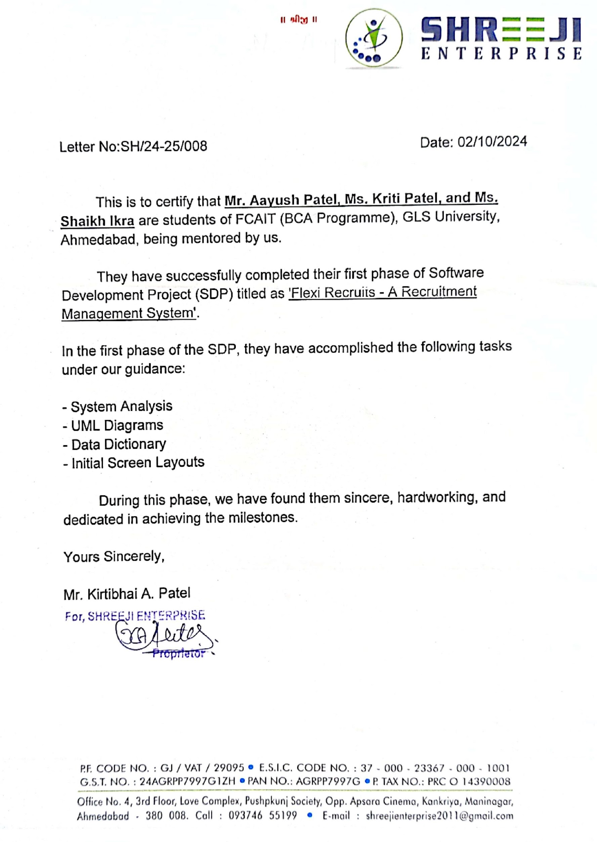

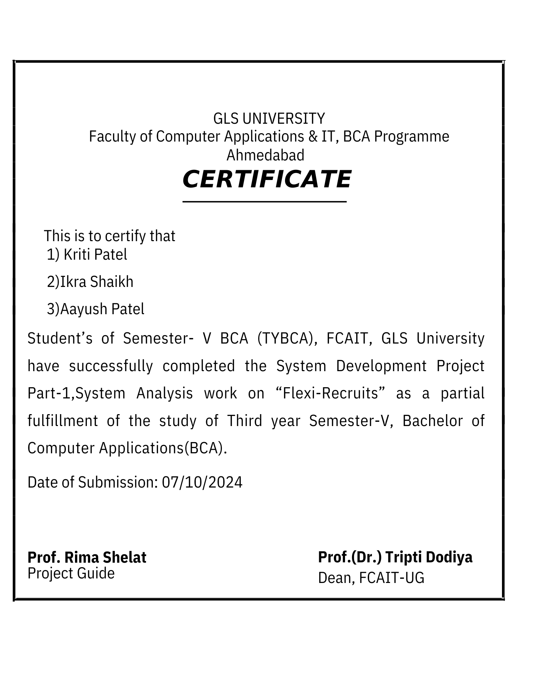

**ACKNOWLEDGEMENT**

We would like to express our sincere gratitude to our **Dean, Faculty of Computer Applications and IT, R.P. Soni** sir and our **Project Head, Dr. Ankit Bhavsar** sir for providing us constant support and mentoring from the institute. We are very thankful to our **Project Guide Prof. Poonam Dang** mam for her encouragement and constant support during the research and development conducted during this project. This project would have not been successful without their guidance and mentoring.

We would also like to thank Faculty of Computer Applications and IT for giving us this opportunity to explore a new field of research and provide essential resources for the same.

Also, we are very thankful to our external guide **Director (Administration), Amogh Technopreneurs LLP, Mr. Amit Finaviya** for supporting and guiding us always.

Through this project we learnt teamwork, new technologies, programming languages, hardware and also discovered a new domain in the field of computer applications.

**Index**

| **Sr No.** | **Content** | **Page No.** |
| --- | --- | --- |
| 1. | Company Profile | 6 |
| 2. | Project Profile | 7 |
| 3. | UML Diagrams | 10 |
| 4. | Data Dictionary | 21 |
| 5. | Sample Screen Layouts | 29 |
| 6. | Conclusion | 31 |

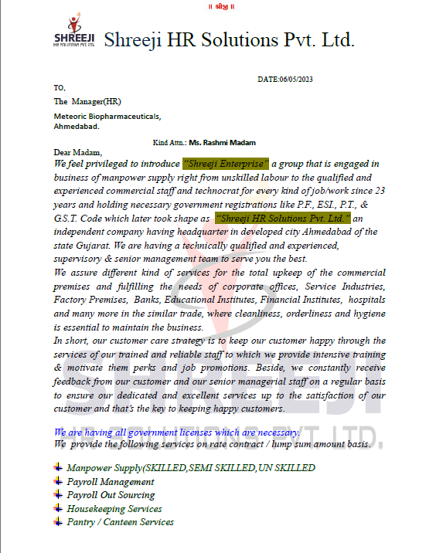

**PROJECT PROFILE**

**Title** - Flexi Recruits

**OBJECTIVE:** To develop an integrated and cost-effective recruitment platform that streamlines the hiring process by identifying qualified candidates for job opportunities. The system will have the capability to match job seekers with relevant positions based on their skills, experience, and preferences, while providing real-time data and insights to the hiring organization. This will help organizations efficiently recognize top talent and take appropriate actions to hire the right candidates, thus improving overall recruitment efficiency and reducing time-to-hire.

**PROJECT DESCRIPTION :**

**i)** Our platform enables organizations to accurately source and manage talent for their staffing needs. It efficiently matches job seekers with relevant opportunities using data on skills, experience, and preferences.

**ii)**  Flexi Recruit integrates advanced search and filtering tools, allowing employers to post job requirements and find candidates that meet specific criteria. The platform ensures that each job posting is categorized effectively for easy access by job seekers.

**iii)**  Each candidate’s profile, including skills and work history, is stored and updated within the system. Employers can view detailed profiles, while job seekers can apply for jobs directly through the platform.

**iv**) Once the hiring process is completed, the contract between the company and the selected candidate is facilitated and managed via the platform. The contracts, along with associated hiring documentation, are securely stored and can be accessed at any time.

**v)** An integrated communication module allows employers and candidates to communicate directly, ensuring smooth coordination from application to job offer. Both parties can track the application status, negotiate contract terms, and finalize hiring decisions in real-time.

**vi)**  A dedicated mobile application is available for job seekers, allowing them to browse job listings, apply for positions, and communicate with employers directly from their smartphones. The app also offers notifications for new job postings and interview requests.

**vii)** The platform also features a feedback system, where employers and job seekers can provide reviews and ratings after the hiring process. This feature ensures transparency and accountability within the platform.

**Tools and Technologies used (Module-wise)**

i) **Admin Module** This module allows administrators to manage users, job postings, applications, and contracts.  It provides a centralized platform for administrative tasks, ensuring efficient management of the system.

Technologies to be used:

* Frontend: HTML, CSS, JavaScript
* Backend: Java, PHP, MySQL

ii) **Job Seeker Module** This module provides job seekers the ability to create profiles, search and apply for jobs, and communicate with employers.  It offers a user-friendly interface for job seekers to manage their job search activities.

Technologies to be used:

* Frontend: HTML, CSS, JavaScript
* Backend: Java, PHP, MySQL

iii) **Employer Module** This module allows employers to post jobs, search for candidates, and manage the hiring process. It streamlines the recruitment process, enabling employers to find the best candidates for their job openings.

Technologies to be used:

* Frontend: HTML, CSS, JavaScript
* Backend: Java, PHP, MySQL

**Future Scope :** To add Artificial Intelligence for automating the candidate-job matching process, enhancing resume screening, and predicting hiring trends without any human interference.

**Technology to be used:** Python, TensorFlow, PHP

**EXISTING SYSTEM :**

* The current recruitment process relies heavily on manual methods where employers and HR personnel conduct interviews and screenings of candidates. This process is time-consuming and often results in inconsistencies in candidate evaluations and hiring decisions.
* Many organizations depend on traditional job boards and referrals to source candidates, leading to a limited pool of applicants and potentially overlooking qualified talent.
* Employers often manage candidate applications through spreadsheets or basic databases, which lack automation and real-time data analysis capabilities, making it challenging to track applicant progress and manage communication efficiently.
* Communication between job seekers and employers is often fragmented, relying on emails or phone calls, which can lead to miscommunication and delays in the hiring process.

**PROPOSED SYSTEM FOR FLEXI RECRUITS :**

* Our proposed system will automate the recruitment process by leveraging advanced algorithms to accurately match candidates with job listings, minimizing the reliance on manual screening and reducing time spent on candidate evaluations.
* The proposed platform will incorporate real-time data analytics to track hiring trends, identify skill gaps, and forecast workforce needs, allowing companies to make informed decisions about talent acquisition and management.
* To enhance user experience, an intuitive web and mobile application will facilitate seamless communication between job seekers and employers, enabling candidates to receive updates on their applications and allowing recruiters to manage the hiring workflow efficiently.
* Feedback and review mechanisms will be integrated to gather insights from users, ensuring continuous improvement of the platform and fostering a transparent recruitment environment.
* Additionally, our system will provide analytics dashboards for both employers and candidates, offering insights into application statuses, hiring trends, and overall performance metrics, thus promoting efficient decision-making and enhancing user satisfaction.

**UML DIAGRAMS**

**1. Use-Case Diagram**

**Actors:**

**1**) ADMIN: Manages the overall system, including user accounts, data, and potentially system settings.

**2)** LABOUR/JOB SEEKER: Individuals looking for employment opportunities.

**3)** CUSTOMER/COMPANY: Organizations posting job listings and searching for candidates.

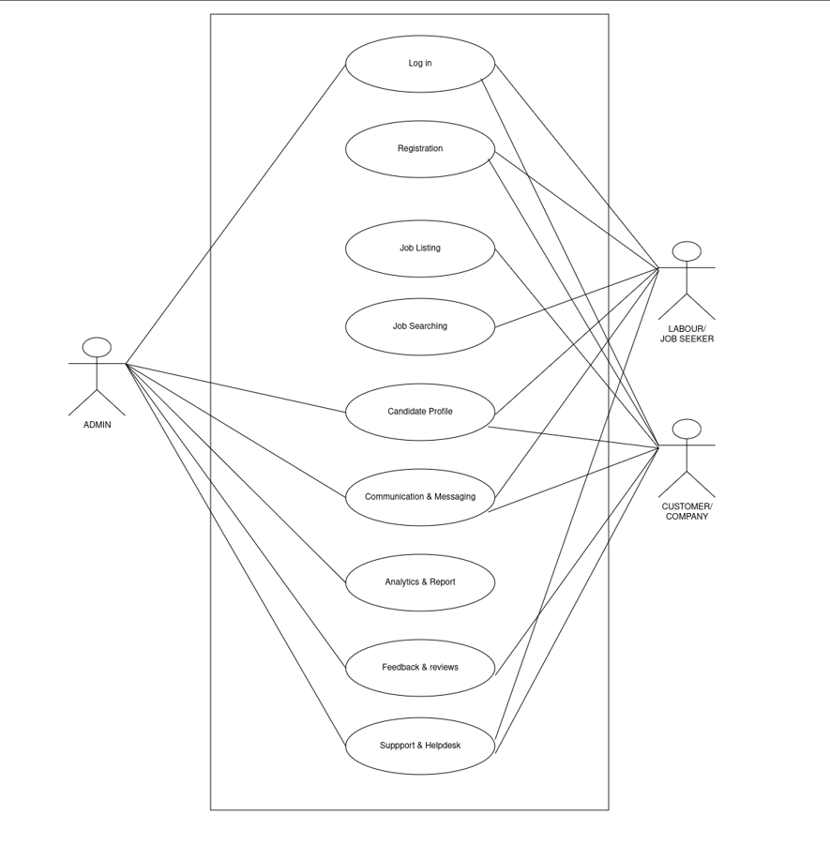

**2. Class Diagram**

**Classes :**

* **Admin:** Represents the system administrator, responsible for managing job listings, users, generating reports, providing support, and archiving data.
* **Company:** Represents companies using the platform to post jobs, view candidates, and analyze data.
* **JobSeeker:** Represents individuals searching for jobs, managing their profiles, applying for jobs, and interacting with the platform.
* **JobListing:** Represents individual job postings, including their description, status, and type.
* **Support:** Manages user support requests, tracking their status and resolution.
* **Feedback:** Stores user feedback on the platform, including ratings and comments.
* **Communication:** Handles communication between users, including sending and receiving messages.
* **JobSearching:** Facilitates job searching functionality, storing search queries and displaying results.

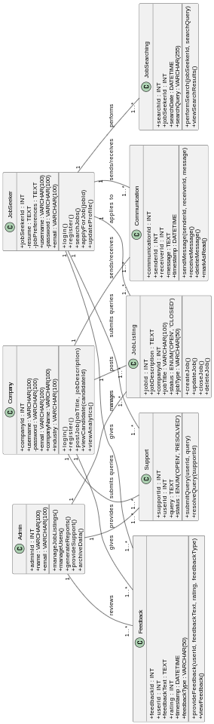

**3. Sequence Diagram:**

The Sequence Diagram depicts interaction between objects in a sequential order i.e. the order in which these interactions take place. It represents individual use cases.

**1). Login**

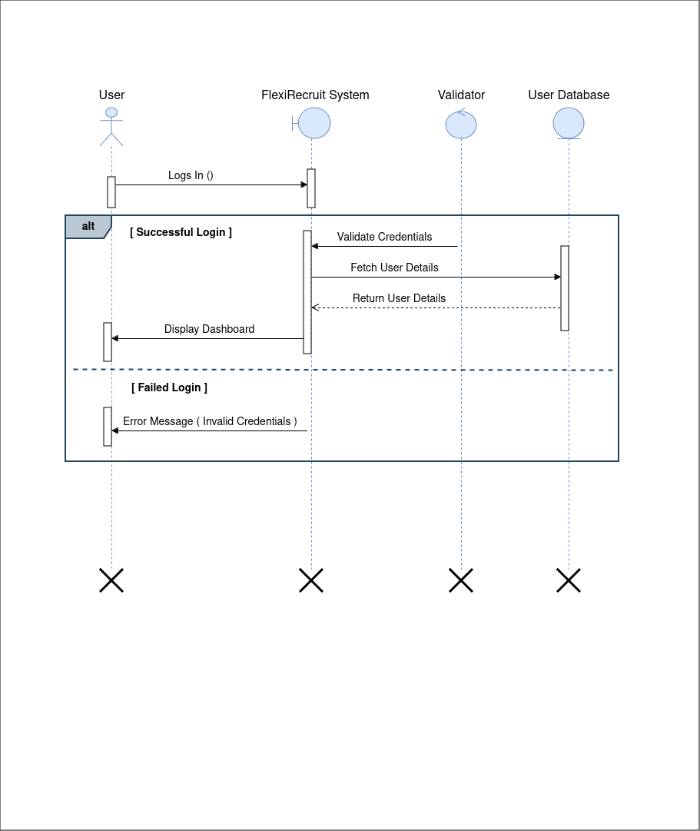

**2). Register**

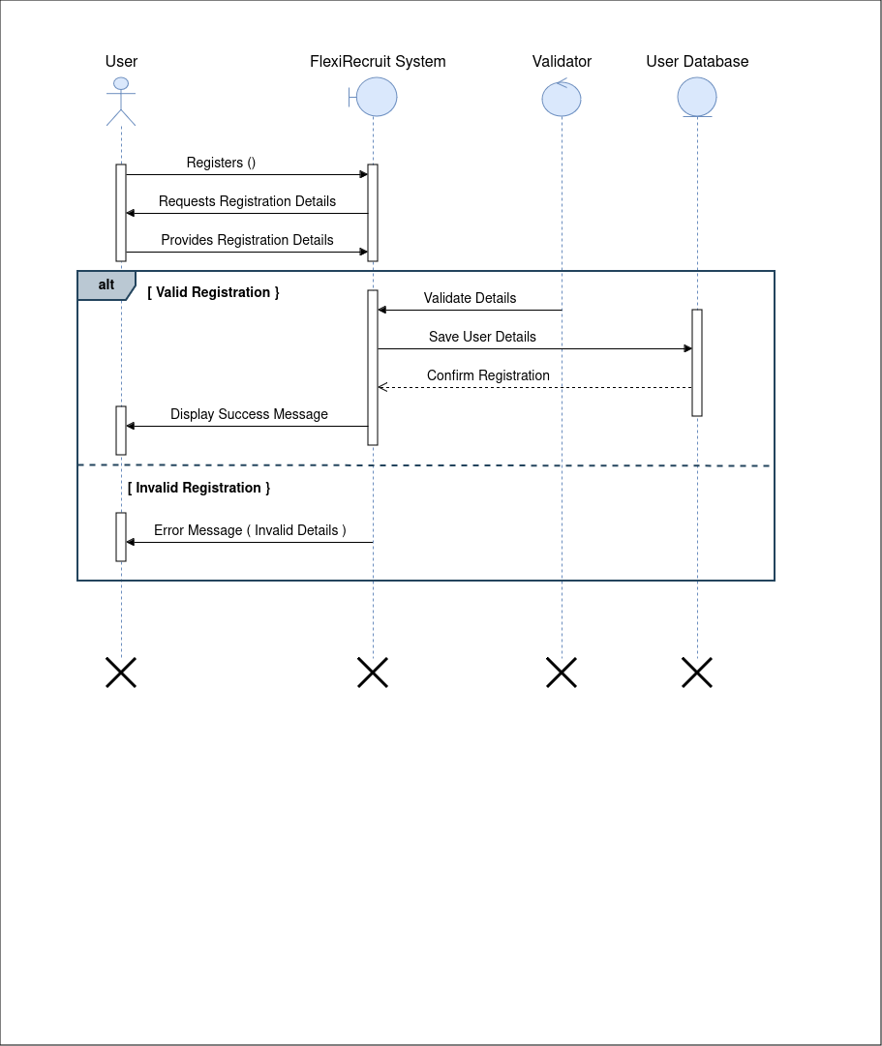

**3). Job-Listing**

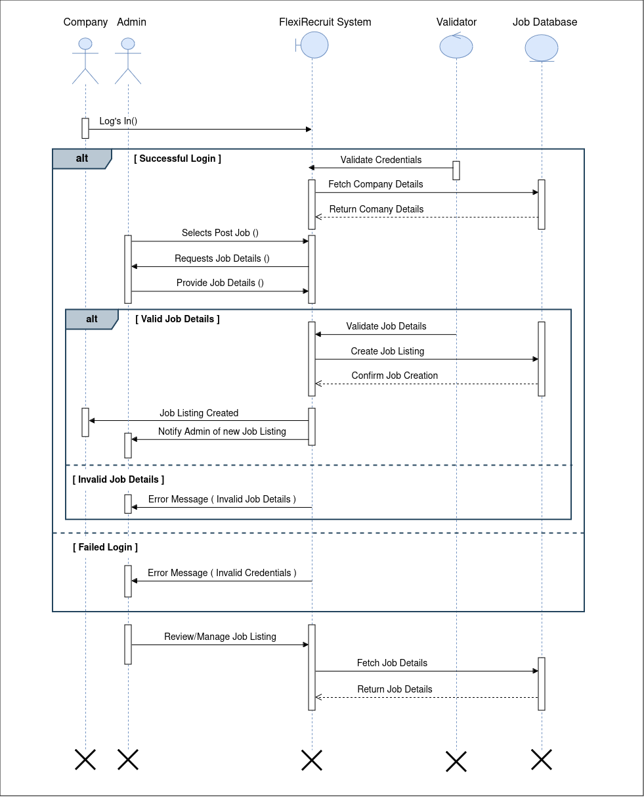



**4). Job-Searching**

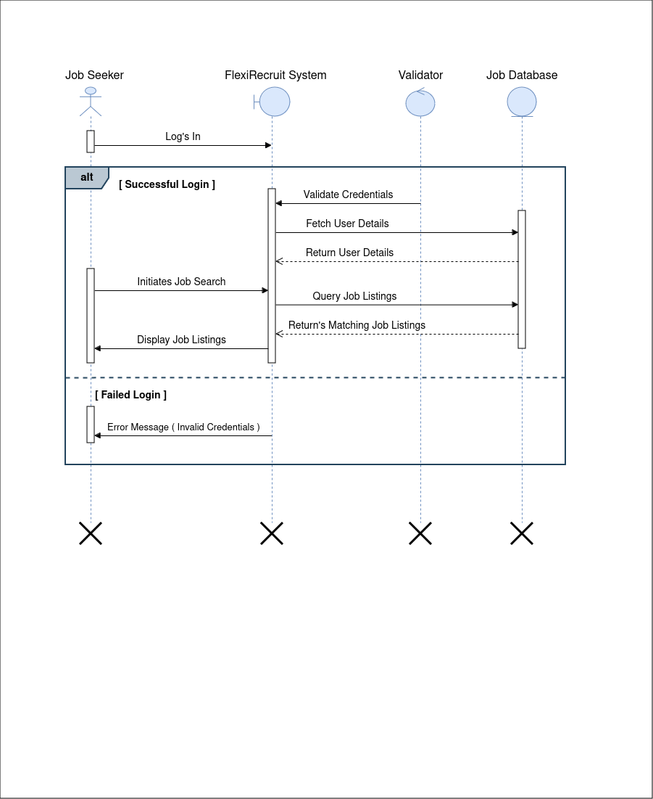

**4. Activity Diagram:**

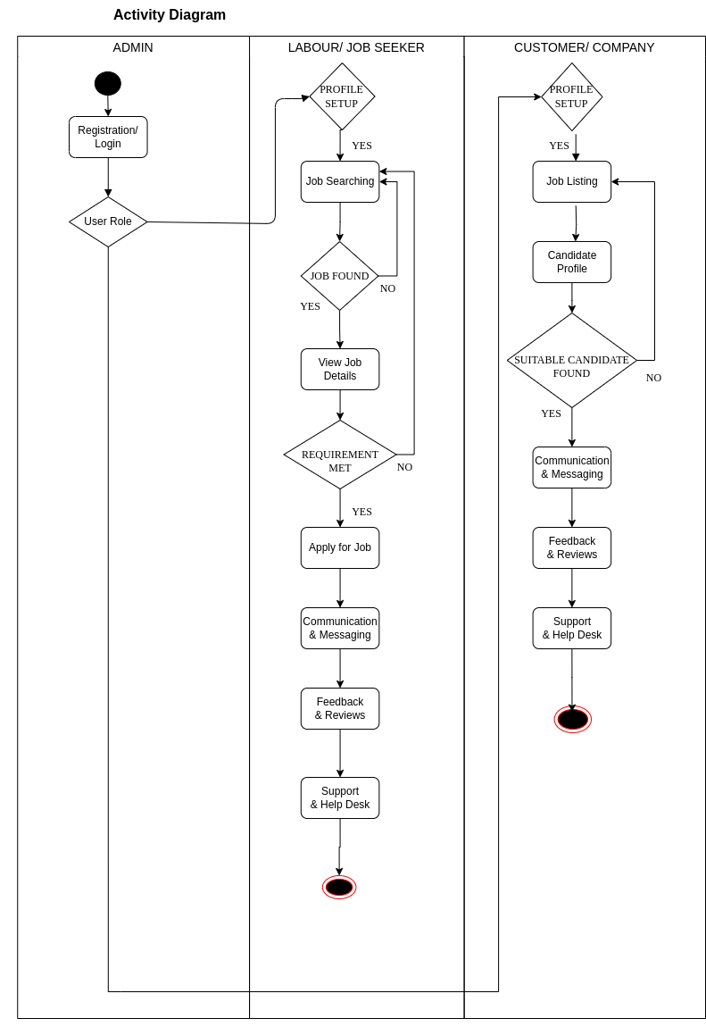

**5. State Chart Diagram:**

**1). Application**

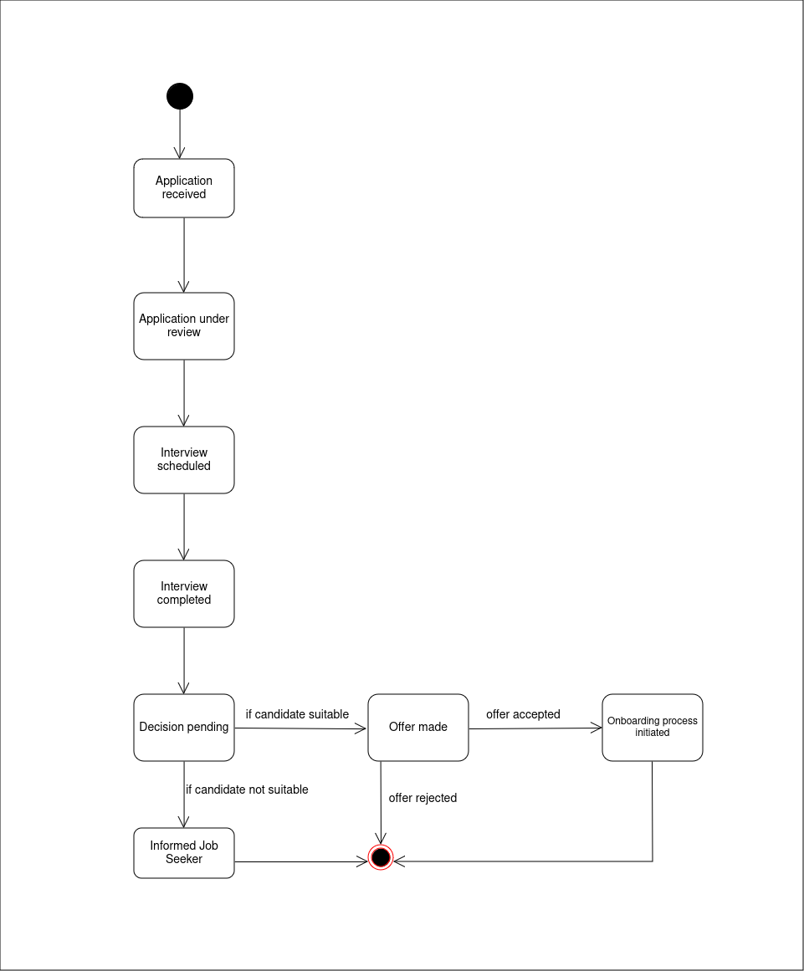

**2). Hiring**

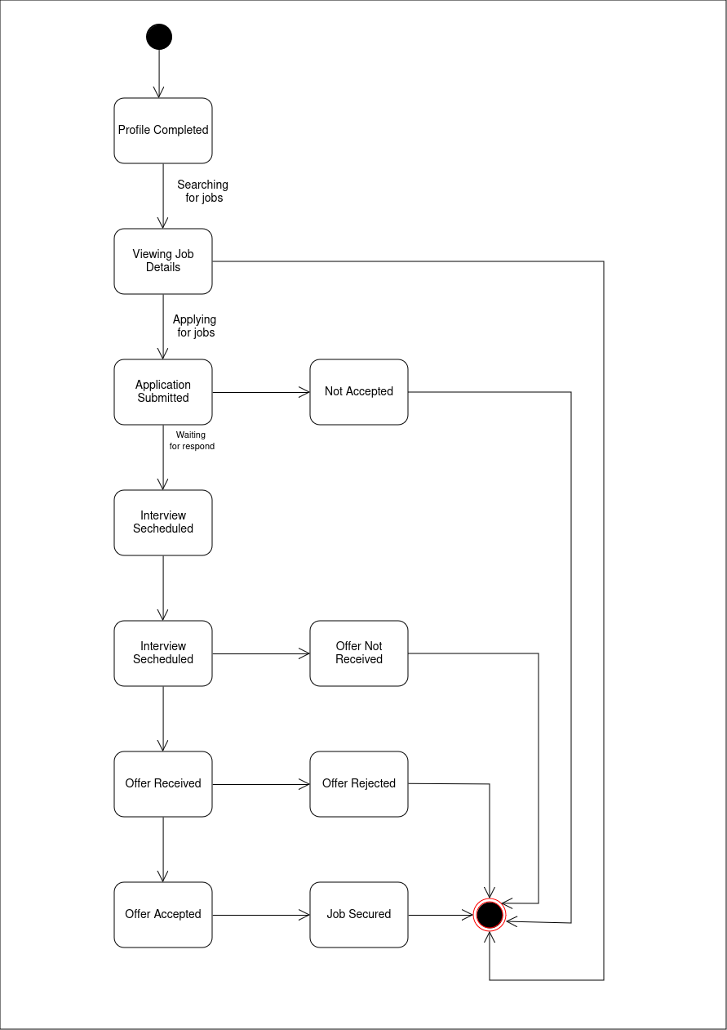

**Data Dictionary**

**1. Table: Admin**

**Description:** The Admin table stores information about administrators, each identified by a unique “adminId”.

**Primary key: AdminId**

**Foreign key:NUll**

## Admin

| **Column Name** | **Data Type** | **Constraints** | **Description** |
| --- | --- | --- | --- |
| adminId | INT | PRIMARY KEY, AUTO_INCREMENT | Unique Admin ID. |
| name | VARCHAR(100) | NOT NULL | Admin's name. |
| email | VARCHAR(100) | NOT NULL, UNIQUE | Admin's email. |
| username | VARCHAR(100) | NOT NULL, UNIQUE | Admin's username for login. |
| password | VARCHAR(100) | NOT NULL | Admin's login password. |

**2. Table:Company**

**Description:** The Company table stores information about companies, including their login credentials, contact details, and industry.

**Primary Key: companyId**

**Foreign Key:NULL**

## 

## Company

| **Column Name** | **Data Type** | **Constraints** | **Description** |
| --- | --- | --- | --- |
| companyId | INT | PRIMARY KEY, AUTO_INCREMENT | Unique Company ID. |
| username | VARCHAR(100) | NOT NULL, UNIQUE | Company login username. |
| password | VARCHAR(100) | NOT NULL | Company login password. |
| email | VARCHAR(100) | NOT NULL, UNIQUE | Company email address. |
| companyName | VARCHAR(100) | NOT NULL | Name of the company. |
| industry | VARCHAR(100) | NOT NULL | Industry type. |

**3. Table: Job-seeker**

**Description:** The JobSeeker table stores information about job seekers, including their resume, job preferences, login credentials, and contact details**.**

**Primary Key:jobSeekerId**

**Foreign Key:NULL**

JobSeeker

| **Column Name** | **Data Type** | **Constraints** | **Description** |
| --- | --- | --- | --- |
| jobSeekerId | INT | PRIMARY KEY, AUTO_INCREMENT | Unique Job Seeker ID. |
| resume | TEXT | NULL | Job Seeker's resume details. |
| jobPreferences | TEXT | NULL | Job Seeker's job preferences. |
| username | VARCHAR(100) | NOT NULL, UNIQUE | Job Seeker login username. |
| password | VARCHAR(100) | NOT NULL | Job Seeker login password. |
| email | VARCHAR(100) | NOT NULL, UNIQUE | Job Seeker email address. |

## 

**4. Table: Job-listing**

**Description**: The JobListing table stores information about job postings, including the job description, company details, status, type, location, and required qualifications.

**Primary Key: jobId**

**Foreign Key: companyId**

## JobListing

| **Column Name** | **Data Type** | **Constraints** | **Description** |
| --- | --- | --- | --- |
| jobId | INT | PRIMARY KEY, AUTO_INCREMENT | Unique Job Listing ID. |
| jobDescription | TEXT | NULL | Description of the job. |
| companyId | INT | NOT NULL, FOREIGN KEY REFERENCES Company(companyId) | Reference to Company. |
| jobTitle | VARCHAR(100) | NOT NULL | Title of the job. |
| status | ENUM('OPEN','CLOSED') | NOT NULL | Job status: open or closed. |
| jobType | ENUM('FULL-TIME', 'PART-TIME', 'CONTRACT', 'FREELANCE') | DEFAULT 'FULL-TIME' | Type of job. |
| location | VARCHAR(255) | NULL | Location of the job. |
| qualifications | TEXT | NULL | Required qualifications for the job. |

**5. Table: Job-searching**

**Description**: The JobSearching table stores information about job searches performed by job seekers, including the search date, query, and the job seeker's ID.

**Primary Key: searchId**

**Foreign Key: jobseekerId**

## JobSearching

| **Column Name** | **Data Type** | **Constraints** | **Description** |
| --- | --- | --- | --- |
| searchId | INT | PRIMARY KEY, AUTO_INCREMENT | Unique Job Search ID. |
| jobSeekerId | INT | NOT NULL, FOREIGN KEY REFERENCES JobSeeker(jobSeekerId) | Reference to the Job Seeker. |
| searchDate | DATETIME | NOT NULL | Date and time of the job search. |
| searchQuery | VARCHAR(255) | NOT NULL | Search query made by the job seeker. |

## 

**6. Table: Communication**

**Description:** The Communication table stores messages exchanged between job seekers, companies, and administrators. It captures the sender's and recipient's IDs, the message content, and the timestamp.

**Primary key: communinationId**

**Foreign key: jobSeekerId,**

**companyId,**

## Communication

| **Column Name** | **Data Type** | **Constraints** | **Description** |
| --- | --- | --- | --- |
| communicationId | INT | PRIMARY KEY, AUTO_INCREMENT | Unique Communication ID. |
| companyId | INT | NULL, FOREIGN KEY REFERENCES Company(companyId) | Reference to Company (if applicable). |
| jobSeekerId | INT | NULL, FOREIGN KEY REFERENCES JobSeeker(jobSeekerId) | Reference to Job Seeker (if applicable). |
| adminId | INT | NOT NULL , FOREIGN KEY REFERENCES admin(adminId) | Reference to Admin. |
| message | TEXT | NOT NULL | Communication message details. |
| timestamp | DATETIME | DEFAULT CURRENT_TIMESTAMP | Timestamp of the communication. |

**7. Table: Feedback**

**Description:** The Feedback table stores ratings and reviews provided by job seekers about companies, including the rating score and timestamp.

**Prmary Key: feedbackId**

**Foreign Key:companyId, jobseekerId.**

## 

## Feedback

| **Column Name** | **Data Type** | **Constraints** | **Description** |
| --- | --- | --- | --- |
| feedbackId | INT | PRIMARY KEY, AUTO_INCREMENT | Unique Feedback ID. |
| companyId | INT | NULL, FOREIGN KEY REFERENCES Company(companyId) | Reference to Company (if applicable). |
| jobSeekerId | INT | NULL, FOREIGN KEY REFERENCES JobSeeker(jobSeekerId) | Reference to Job Seeker (if applicable). |
| feedbackText | TEXT | NOT NULL | Feedback content. |
| rating | INT | NOT NULL CHECK (rating >= 1 AND rating <= 5) | Feedback rating (1 to 5). |
| timestamp | DATETIME | DEFAULT CURRENT_TIMESTAMP | Timestamp for the feedback entry. |

## 

**8. . Table: Support**

**Description:** The Support table stores support requests or queries submitted by job seekers, including the job seeker's ID and the query details.

**Primary Key: supportId**

**Foreign Key: jobSeekerId**

## Support

| **Column Name** | **Data Type** | **Constraints** | **Description** |
| --- | --- | --- | --- |
| supportId | INT | PRIMARY KEY, AUTO_INCREMENT | Unique Support Query ID. |
| companyId | INT | NULL, FOREIGN KEY REFERENCES Company(companyId) | Reference to Company (if applicable). |
| jobSeekerId | INT | NULL, FOREIGN KEY REFERENCES JobSeeker(jobSeekerId) | Reference to Job Seeker (if applicable). |
| query | TEXT | NOT NULL | Support query details. |
| status | ENUM('OPEN', 'RESOLVED') | NOT NULL | Status of the support query. |

## 

**Sample Screen Layouts**

**1.HomeScreen**

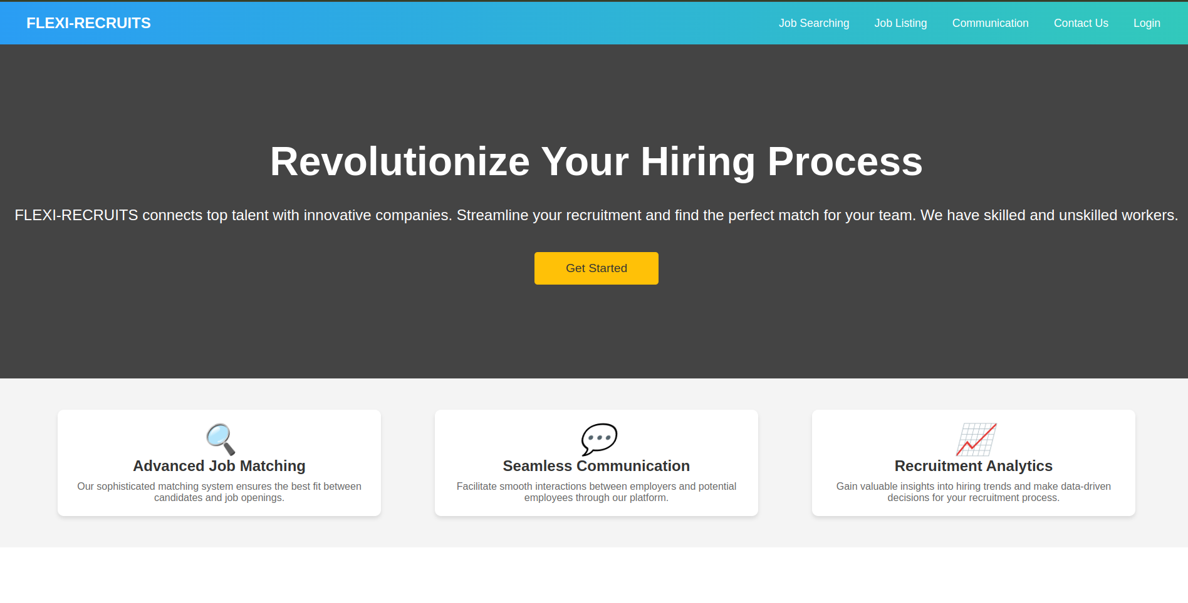

**2. Sign-in**

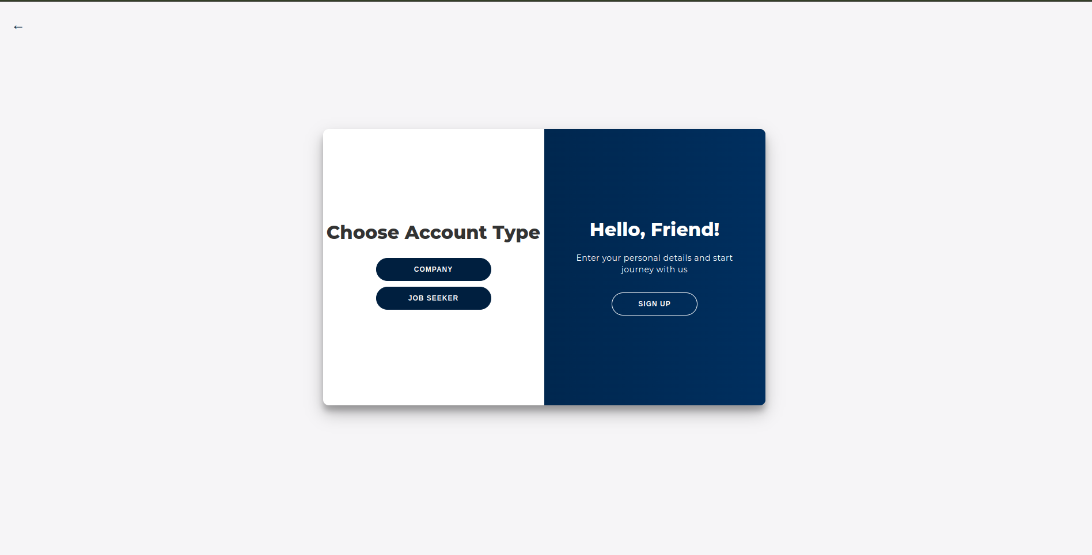

**3.Register**

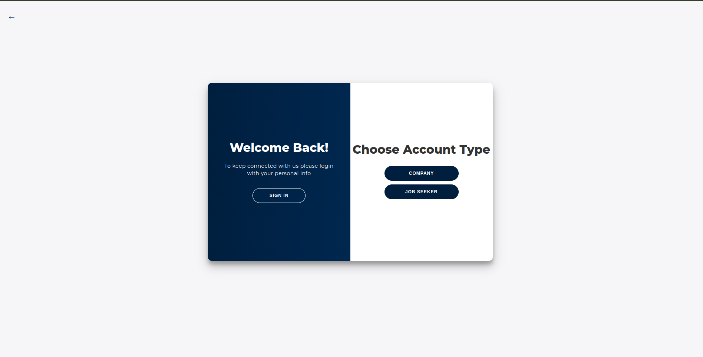

**CONCLUSION**

The practical implementation of the Flexi Recruit system is essential for managing the complexities of the modern recruitment landscape, where organizations face an overwhelming volume of applications and diverse candidate profiles. This platform has demonstrated its capability to streamline the hiring process, enabling faster and more efficient matching of candidates to job opportunities.

By automating candidate screening and leveraging data analytics, this system ensures that employers can make informed hiring decisions, thereby reducing the time and effort spent on manual evaluations. The integration of AI-driven recommendations will allow hiring managers to focus on the most suitable candidates, enhancing the overall quality of hires.

Moreover, Flexi Recruit empowers both job seekers and employers by providing real-time insights into application statuses, hiring trends, and performance metrics. This transparency fosters trust and accountability in the recruitment process.

Ultimately, the implementation of this system will not only improve operational efficiency but also enhance the overall user experience for both candidates and organizations. By addressing the critical pain points in traditional recruitment methods, Flexi Recruit aims to redefine how companies approach talent acquisition, leading to more successful hiring outcomes and a more satisfied workforce